PHASE 5: Streaming Dashboard Development

Step 1: Create Dashboard Directory
Open a NEW Terminal (Terminal 6) - Keep all 5 existing terminals running!
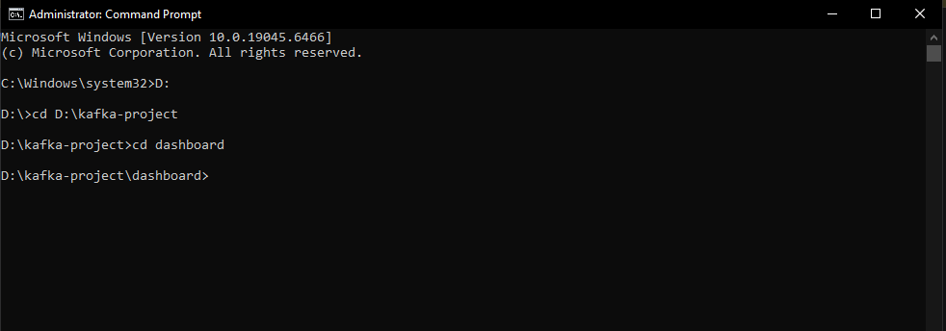

Step 2: Install Dashboard Dependencies

Verify installation:
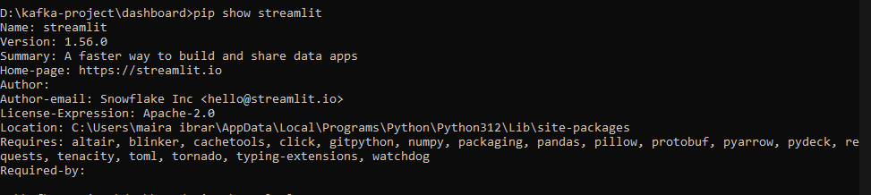
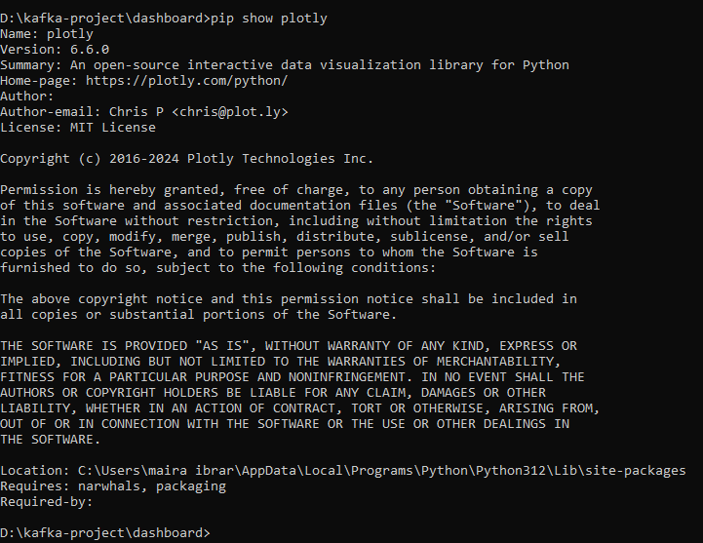

Step 3: Create Dashboard Configuration File
Create: D:\kafka-project\dashboard\config.py
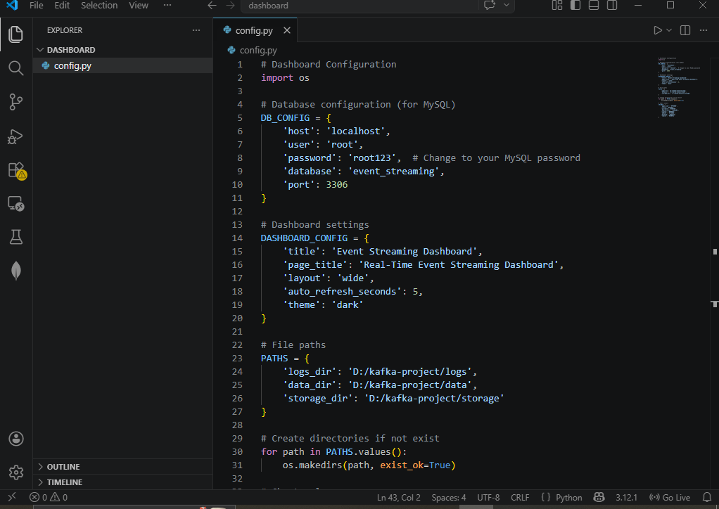

Step 4: Create Dashboard Database Helper
Create: D:\kafka-project\dashboard\db_helper.py
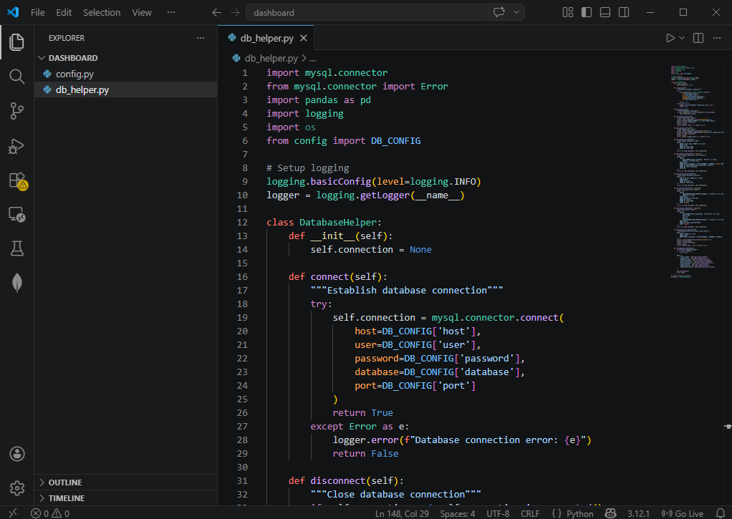

Step 5: Create Main Dashboard File
Create: D:\kafka-project\dashboard\dashboard.py
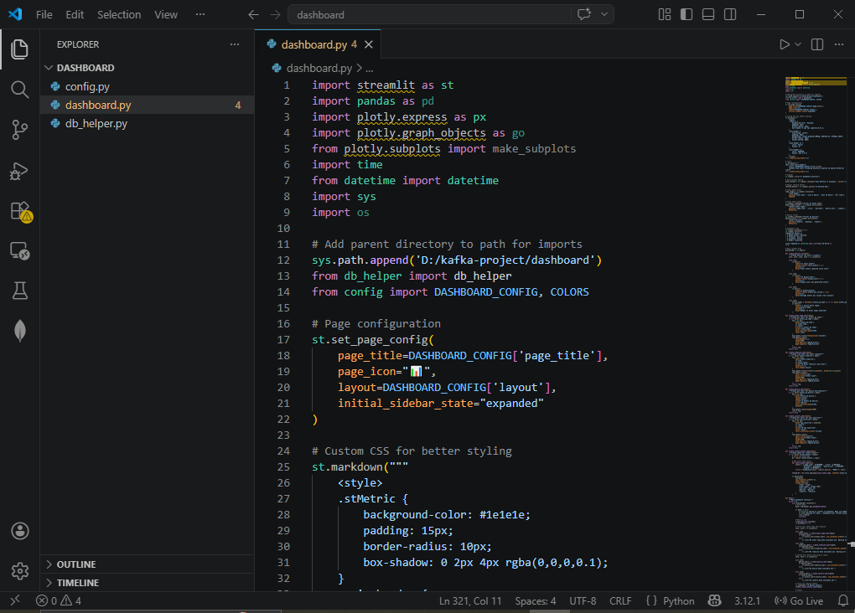

Step 6: Create Dashboard Launcher Script
Create: D:\kafka-project\dashboard\run_dashboard.bat
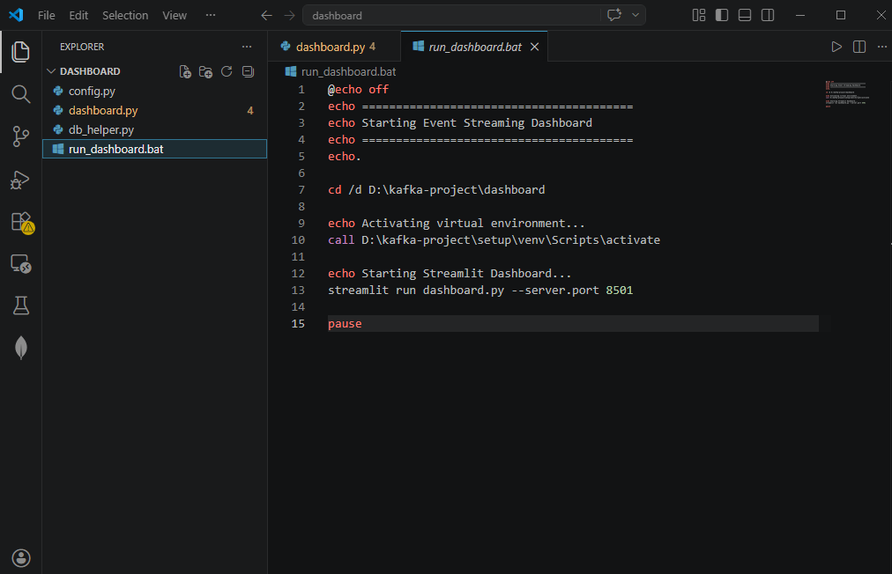

Step 7: Create Alternative Dashboard (Without Database - JSON Only)
Create: D:\kafka-project\dashboard\dashboard_json.py (Fallback if MySQL issues)
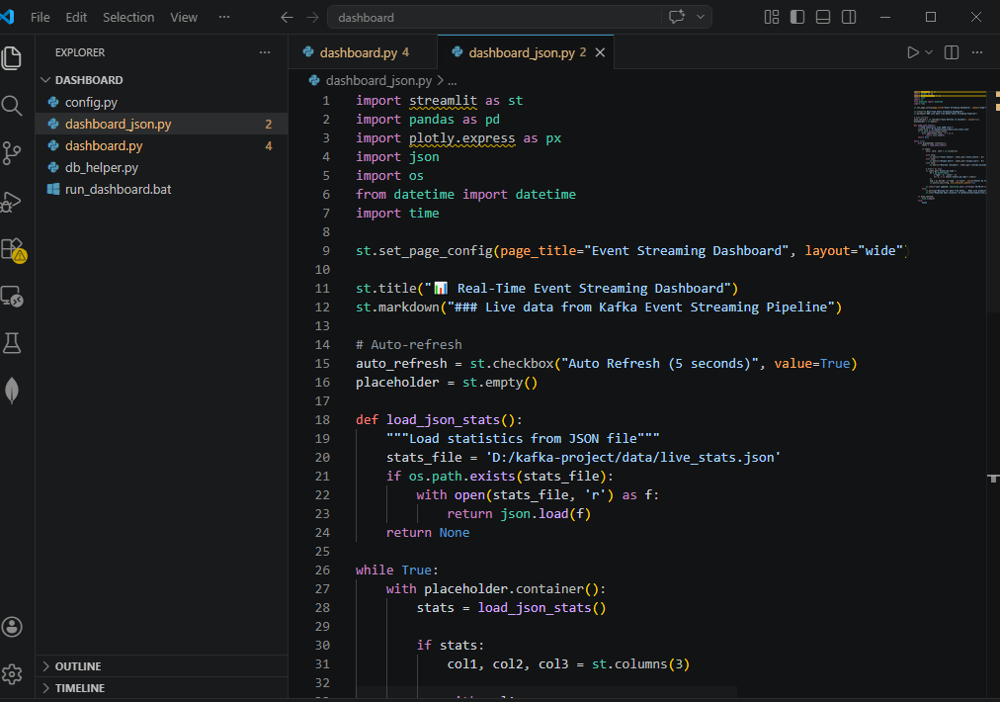

Step 8: Run the Dashboard

Using Batch File
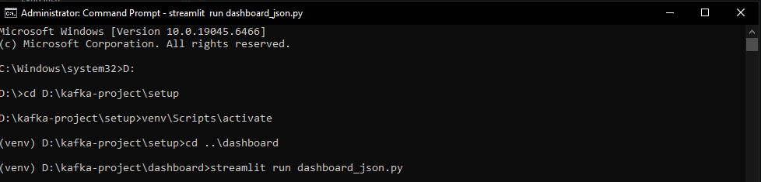

Step 9: Access the Dashboard
You can now view your Streamlit app in your browser.
Local URL: http://localhost:8501
Network URL: http://192.168.x.x:8501
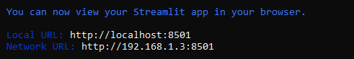

SEEING FULL DASHBOARD:
- ctrl +c on consumer_live.py
